Test case 1: 40 hours worked

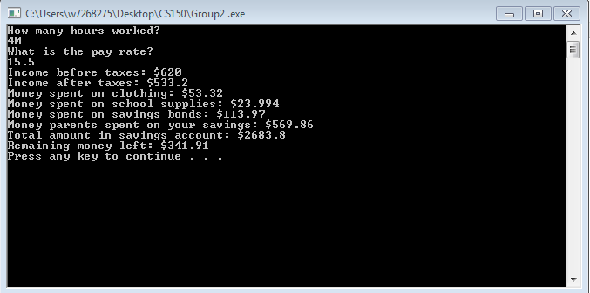

Test case 2: 200 hours

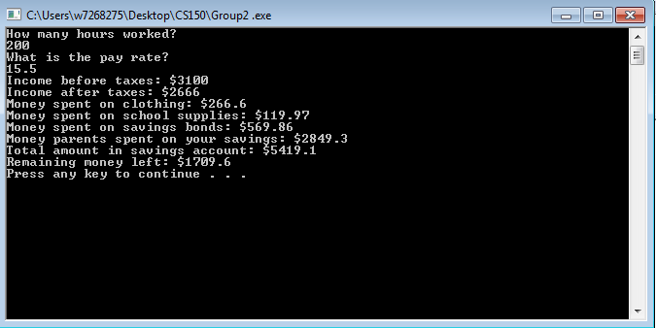

/*

Group2.cpp:

will calculate money spent on a variety of things such as school

supplies, bonds, and income amount before and after income tax

has been applied. Ask user for input of hours and display

calculations to console at end of program

@author Jose A Huerta, Pedro Suazo, Akhil Bharadhwaj, Mikhail Ottewell

@version 1.0

Algorithm

START OF PROGRAM

DECL hours, income, payRate, taxRate, clothTotal,

clothPercentage, schoolTotal, schoolPercentage,

savingsPercentage, currentSavings, balance

CALC income = payRate * hours

CALC incomeAfterTax = income (income * taxRate)

SET balance = incomeAfterTax

CALC clothTotal = income* clothPercentage

CALC balance -= clothTotal

CALC schoolTotal = balance * schoolPercentage

CALC balance -= schoolTotal

CALC bonds = balance * savingsPercentage

CALC bonds = bonds * 5

CALC currentSavings += bonds

DISPLAY all calculations to user

END OF PROGRAM

*/

#include <iostream>

using namespace std;

int main()

{

int hours;

double income, payRate, clothTotal, schoolTotal, savingsTotal, balanceTotal,

bondsTotal, incomeAfterTax, taxTotal, parentsBonds;

const double TAX_RATE = .14;

const double CLOTH_RATE = .1;

const double SCHOOL_RATE = .05;

const double SAVINGS_RATE = .25;

savingsTotal = 2000;

cout << "How many hours worked?" << endl;

cin >> hours;

cout << "What is the pay rate?" << endl;

cin >> payRate;

income = payRate * hours;

incomeAfterTax = income - (income * TAX_RATE);

balanceTotal = incomeAfterTax;

clothTotal = balanceTotal * CLOTH_RATE;

balanceTotal -= clothTotal;

schoolTotal = balanceTotal * SCHOOL_RATE;

balanceTotal -= schoolTotal;

bondsTotal = balanceTotal * SAVINGS_RATE;

balanceTotal -= bondsTotal;

parentsBonds = bondsTotal * 5;

savingsTotal += bondsTotal + parentsBonds;

cout.precision(5);

cout << "Income before taxes: $" << income << endl <<

"Income after taxes: $" << incomeAfterTax << endl <<

"Money spent on clothing: $" << clothTotal << endl <<

"Money spent on school supplies: $" << schoolTotal << endl <<

"Money spent on savings bonds: $" << bondsTotal << endl <<

"Money parents spent on your savings: $" << parentsBonds << endl <<

"Total amount in savings account: $" << savingsTotal << endl <<

"Remaining money left: $" << balanceTotal << endl;

system("Pause");

return 0;

}